Thisse Lab - In Situ Hybridization Protocol – 2010 Update

High resolution in situ hybridization (ISH) to whole-mount zebrafish embryos

updated from:
Thisse, C. and Thisse, B. (2008) High resolution in situ hybridization on whole-mount zebrafish embryo. Nat. protoc. 3: 59 – 69

There are several ways to perform each step required for whole mount ISH. We choose to describe here an experimental procedure that optimizes the conditions to perform high throughput analysis and to get a high-resolution analysis of gene expression. Nevertheless, this protocol is also appropriate for analysis of the expression of a single gene at one particular developmental stage.

In situ protocol short version

A - Probe synthesis
Component | Amount per reaction | Final
Linear Template DNA | 2.5µl | 100-200 ng
5x Transcription buffer | 1µl | 1X
DTT 0.1M | 0.5µl | 10 mM
DIG-RNA labeling mix (UTP) | 0.5 µl
RNAsein (40U/µl) | 0.25 µl | 10 U
T3 or T7 RNA polymerase (20U/µl) | 0.25 µl | 5U

Mix and incubate 2 h at 37°C.
Add 2 µl RNAse free DNAse I and 18 µl sterile water. Mix and incubate for 30 min at 37°C.
Stop the reaction by adding 1 µl sterile 0.5 M EDTA and 9 µl sterile water.
Place a Sigmaspin Post Reaction Purification column on top of a microfuge tube. Centrifuge 15 s at 750 g.
Break the base of the column and discard lid. Spin 2 min at 750 g.
Place the column on a new microfuge tube. Add the RNA template on top of the resin. Centrifuge 4min at 750 g. Discard the column.
Add 1 µl sterile EDTA 0.5M and 9 µl of RNAlater to the sample; this protects the RNA from degradation. Test 1/10 of the synthesis on agarose gel.

B – Embryo / Larva collection, chorion removal, fixation, storage

Collect the eggs.

Place embryos in a 100 ml beaker, covered with a minimal amount of water (10 ml).
Pour 3 ml Pronase (1/100 wt/vol, warmed to 28.5°C) into the beaker and incubate for 1 min.
Gently rinse the eggs 3 times with fish water.
Place the embryos in large Petri dishes (50 embryos maximum for a 94 mm Petri dish, 600 embryos for a 145 mm Petri dish) coated with 2% agarose.

Let the embryos develop at 28.5°C until the most of the chorions have been removed. Collect the dechorionated embryos by pouring them in a new Petri dish.

Continue to incubate the embryos at 28.5°C in Petri dishes containing fish water until the desired developmental stage is reached. If post-gastrulation stages are to be examined, the formation of melanin pigment needs to be prevented. This can be achieved by replacing regular fish water with 0.0045% 1-Phenyl-2-Thiourea (PTU) solution prepared in 0.3 x Danieau medium at the end of gastrulation. For larva and embryos older than 24 hours post fertilization (hpf) change this medium once a day.

Fix dechorionated embryos of the appropriate developmental stage(s) in 4% (wt/vol) paraformaldehyde in 1 x PBS overnight at 4°C into Petri dishes.

(Alternatively, embryos can be dechorionated, after fixation in PFA, by hand using sharpened forceps – Dumond 5 Switzerland).

The next day, dehydrate the embryos in 100% methanol for 15 min at room temperature.

Place the eggs at -20°C in 100 % methanol for at least two hours before use. Embryos can be kept at -20°C in methanol for several months.

C – In situ hybridization

Step 1 : Permeabilization of embryos: Day 1

1. Rehydratation.
- 1 x 5 mn 100% Methanol
- 1 x 5 mn 75% Methanol -25% PBS
- 1 x 5 mn 50% Methanol -50% PBS
- 1 x 5 mn 25% Methanol -75% PBS
- 4 x 5 mn PBT (PBS 1 x / tween20 0.1%)

2. Permeabilization of embryos.
Digestion with proteinase K (PK)
Final solution at 10 µg/ml in PBT (test appropriate time for every new batch of PK)
For embryos at 75 % epiboly (Gastrula) 0 - 30 sec
For embryos from 5-6 somites (ES) 1 min
For embryos from 18-20 somites (MS) 3 min
For embryos of 24 h 10 min
For embryos of 36 h 20 min
For embryos of 48 h and later 30 min
Postfixation (stop the proteinase K digestion):
- 20 mn in 4% PFA-PBS
washes:
- 5 x 5 min in PBT
Transfer embryos into 1.5 ml sterile eppendorf tubes

3. Prehybridization of embryos
Incubation from 2 to 5 h at 70°C in 0.6 to 1 ml of hybridization mix (HM). For 50 ml:

Formamide 25,0 ml 50% FA
20 x SSC 12,5 ml 5 SSC
Heparin 5 mg/ml 0,5 ml 50 µg/ml
tRNA 50 mg/ml 0,5 ml 500 µg/ml
Tween 20 20% 0,25 ml 0,1%
Acide citrique 1M 0,46 ml pH 6
H2O to 50 ml
For strong probes that don’t require long labelling incubation time, heparin and tRNA are not essential and can be omitted.
Possible storage in HM for weeks at -20°C or at + 4°C for a day

STEP 2 : Hybridization

Add the antisense DIG labelled RNA:
Remove the HM use for prehybridization
add 200 µl of HM containing 30 - 100 ng of probe (1 - 2 µl of probe synthesis)
Incubate O/N at 70°C in a waterbath

STEP 3 : Washes / Preincubation - Incubation with Ab :
Day 2

1 x quickly with HM (without tRNA and heparin) at 70°C
10 mn 75% HM + 25% 2xSSC à 70°C
10 mn 50% HM + 50% 2xSSC à 70°C
10 mn 25% HM + 75% 2xSSC à 70°C
10 mn 2xSSC à 70°C

2 x 30 mn in 0.2 x SSC at 70°C

10 mn 75 % 0.2xSSC + 25% PBT at RT (room temperature)
10 mn 50 % 0.2xSSC + 50% PBT at RT
10 mn 25 % 0.2xSSC + 75% PBT at RT
10 mn PBT at RT

Preincubation of embryos for Ab labelling

Incubate embryos several hours under agitation in
BSA 2 mg/ml - 2% Sheep serum in PBT

Incubation with Alkaline phosphatase anti DIG antibody

Dilute anti-DIG Ab to 1/5,000 - 10,000
Incubate overnight at 4°C with agitation

Step 4 - Washes / labelling reaction: Day 3

Washes (remove unbound Antibodies)
1 quick wash in PBT at room temperature
6 x 15 mn in PBT at room temperature under gentle agitation
(dry on paper before moving in the next solution)
3 x 5 mn at room temperature in alkaline tris buffer
Alkaline Tris buffer:
Final
Tris HCl pH 9,5 1M 10 ml 100 mM
MgCl2 1M 5 ml 50 mM
NaCl 5M 2 ml 100 mM
Tween 20 20% 0,5 ml 0,1%
H2O to 100 ml

Labelling
Move embryo in eppendorf tubes (remove them first from baskets in a 6 cm petri dish filled with alkaline tris buffer)
remove the excess of alkaline tris buffer and replace with 700 µl of labelling mix freshly prepared

Labelling mix:
225 µl NBT + 50 ml Alkaline Tris buffer + 175 µl BCIP
To decrease background and perform long labelling incubation (24h incubation time at room temperature) NBT solution can be decreased 10x (22.5 µl for 50 ml Alkaline Tris buffer).
22.5 µl NBT + 50 ml Alkaline Tris buffer + 175 µl BCIP

Stock Solutions:
NBT: 50 mg Nitro Blue Tetrazolium dissolved in 0.7 ml de N,N-dimethylformamide anhydrous and 0.3 ml of water (store at -20°C)
BCIP: 50 mg of 5-Bromo 4-Chloro 3-indolyl Phosphate dissolved in 1 ml of N,N-dimethylformamide anhydrous (store at -20°C)

Move embryos with labelling mix into 12 well ceramic plates. Let the reaction occuring in the dark, looking under disecting scope every 15 min for the first hour then every ½ h or 1h after the first hour of reaction.
Stop labelling in PBS pH 5,5 EDTA 1 mM (3 washes, 1 quick and 2 under gentle agitation)
Store at 4°C in PBS pH 5,5 EDTA 1 mM in the dark (labelled embryos can be kept for years)

In situ hybridization on whole mount zebrafish embryo
Detailled Protocol

Stages and timing involved in the Procedure described below.
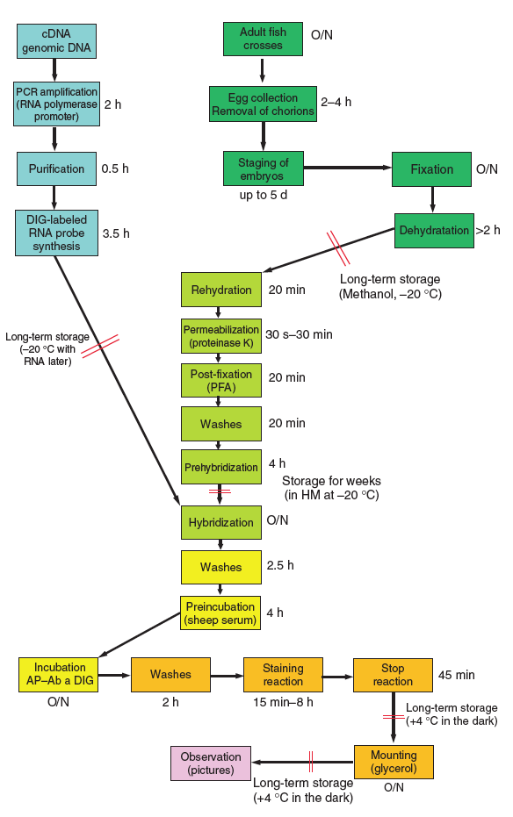
Flow diagram
The different steps of the ISH protocol are indicated into boxes linked by arrows and colored in blue for steps corresponding to synthesis of the probe, in dark green for preparation of embryos, in light green for Day 1 of in situ procedure, in yellow for Day 2, in orange for Day 3 and in pink for the final step. Time required for each step is indicated near the box (O/N: over night). Pause points are indicated in the diagram by two red lines across arrows. Information about the length and conditions of storage is indicated.

Primer design for amplifying probe templates containing an RNA polymerase promoter:
In addition to the use of antisense (experimental) RNA probes, in situ hybridizations using sense (control) RNA probes of the corresponding genes can be performed to provide information about non-specific signals that may appear. Primers should generate linear DNA containing at least one T3 or T7 RNA polymerase promoter, which should be located 3' (for experimental, antisense probes) or 5′ (for control, sense probes) of the sequence corresponding to the cDNA or exon of interest. If there is no T3 or T7 RNA polymerase promoter in the vector containing the gene sequence, or when genomic DNA is used as a template, a T3 or T7 RNA polymerase promoter should be included in the appropriate primer (reverse primer for antisense probes, forward primer for sense probes) used to amplify the probe template. The primer needs to be at least 40 nucleotides long with at least 20 nucleotides complementary to the target DNA; the promoter sequence (T3: 5' CATTAACCCTCACTAAAGGGAA 3' or T7: 5' TAATACGACTCACTATAGGG 3') should be located at the 5' extremity of the primer. For best results the RNA probe (and therefore the DNA template) should be longer than 1 kb. Good labeling may also be obtained with shorter probes, but the minimal size required is approximately 200 bp. When two genes share extensive sequence similarities, getting a specific pattern of expression could be quite challenging. To minimize cross reactivity, the 3’ untranslated region (UTR) of each gene can be used as templates.
Note : SP6 RNA polymerase is very inefficient to incorporate DIG labelled UTP and should not be used to prepare the probe.

DNA template preparation using PCR amplification TIMING 2.5 h
- For each probe (control and experimental), set up a separate 100 µl PCR reaction in a 0.5 ml sterile tube, as tabulated below. Either cDNA inserted in plasmids or genomic DNA can be used as templates for the PCR reaction (see Reagent Setup for details on primer design).

Component | Amount per reaction | Final
Template DNA | 0.5µl | 10-100 ng
Forward primer  (500 ng/µl) | 0.5µl | 250 ng
Reverse primer  (500 ng/µl) | 0.5µl | 250 ng
PCR master mix (2 X) | 50µl | 1X
Sterile water | Up to 100 µl

Sense versions of the experimental antisense probe can be used to as a control for background staining (see Reagent setup). However, we believe that the best method to demonstrate specificity is to obtain identical spatially restricted expression patterns using different non-overlapping probes for the same gene.
Be careful not to contaminate the PCR reactions. Use sterile tubes and filter tips, and wear gloves.
Alternatively to PCR amplification, cDNAs in plasmids can be linearized using restriction enzymes that have a unique site located 5’ (for antisense probes) or 3′ (for sense probes) to the insert. Purification of linear DNA can be achieved by phenol/chloroform extraction followed by ethanol precipitation.

- Run the PCR using the conditions tabulated below.
Cycle number | Denature | Anneal | Extend
1 | 95°C, 4 min | -- | --
2-36 | 95°C, 30s | 55°C, 30s | 72°C, 1 min per kb
37 | -- | -- | 72°C, 7 min

Cool the amplified PCR product to 4°C.
- Add the 100 µl PCR reaction to a Microcon YM-50 column and add 400 µl sterile water. Centrifuge for 15-20 min at 1,000g. The membrane should be dry. If not, centrifuge again.
- Place the Microcon column into a new microfuge tube (provided in the kit), add 20 µl sterile water, vortex briefly and then turn the Microcon column upside down. Spin 1 min at 1,000 g to recover the DNA. The vortexing step should be quick. Centrifuge 1 min only to avoid overdrying of the sample.
Purified PCR products can be stored for several months at -20°C.

- Check quality, quantity and size of the PCR amplification product by loading 1/20 of the preparation on a 1% (wt/vol) agarose gel in 1 x TBE buffer. DNA should appear as a band and not as a smear. 1/20 of the preparation should contain at least 40 ng of DNA

Synthesis of antisense RNA probe TIMING 3.5h
- For each probe, add the components tabulated below to a microfuge tube. Mix and incubate 2 h at 37°C.
Component | Amount per reaction | Final
Template DNA | 2.5µl | 100-200 ng
5x Transcription buffer | 1µl | 1X
DTT 0.1M | 0.5µl | 10 mM
DIG-RNA labeling mix (UTP) | 0.5 µl
RNAsein (40U/µl) | 0.25 µl | 10 U
T3 or T7 RNA polymerase (20U/µl) | 0.25 µl | 5U

- Add 2 µl RNAse free DNAse I and 18 µl sterile water. Mix and incubate for 30 min at 37°C.
- Stop the reaction by adding 1 µl sterile 0.5 M EDTA and 9 µl sterile water.
- Place a Sigmaspin Post Reaction Purification column on top of a microfuge tube. Centrifuge 15 s at 750 g. (Use an RNAse free centrifuge)
- Break the base of the column and discard lid. Spin 2 min at 750 g.
- Place the column on a new microfuge tube. Add the RNA template on top of the resin. Centrifuge 4min at 750 g. Discard the column.
- Add 1 µl sterile EDTA 0.5M and 9 µl of RNA later to the sample; this protects the RNA from degradation.
Purified digoxygenin labeled antisense (or sense) RNA can be stored for months at -20°C. This probe synthesis provides enough antisense (or sense) RNA to perform at least 40 different in situ hybridization reactions.
- Visualize 1/20 of the synthesized RNA on 1% (wt/vol) agarose gel in 1x TBE buffer after 30 min electrophoresis at 230 V. A good probe should appear as one or two discrete bands on the gel, not as a smear – which would indicate degradation.

Egg collection TIMING 2 - 3h
- Set up pairs of male and female fish in breeding tanks the night before eggs are to be collected. Separate the male and female with a diagonal plastic divider.
This enables pheromones to be distributed in the water between male and female compartments of the breeding tank, which facilitates mating the next day. Separating the fish prevents them from fighting.
- The next morning when the light goes on, place the upper part of the breeding tank in a clean lower part filled with fresh water. Remove the divider of the breeding tank and let the fish mate for 10 to 20 min. The eggs laid will sink to the bottom of the breeding tank.
Adult zebrafish in the wild mate when the light comes on. In the fish facility, the vast majority of fish lay between 5 min and 1 h after the light is turned on. Additional eggs can be obtained until late morning.
- Collect the eggs from the bottom tank by pouring them into Petri dishes.
Avoid putting a large number of embryos in the same Petri dish as they will not develop properly (maximum 600 embryos per 145 mm and 50 embryos per 94 mm Petri dish).
- Clean the clutch under a stereomicroscope with a diascopic stand; discard dirt and unfertilized eggs using a Pasteur capillary pipette (with a large opening) and pipette pump filler.

Removal of chorions TIMING 2 - 5 h
- Place embryos in a 100 ml beaker, covered with a minimal amount of water (10 ml).
- Pour 3 ml Pronase (1/100 wt/vol, warmed to 28.5°C) into the beaker and incubate for 1 min. Gentle Pronase treatment progressively softens the chorion without damaging the embryos. Alternatively, embryos can be dechorionated after fixation in PFA, by hand using sharpened forceps (Dumont 5).
- After the 1 min incubation, fill the beaker with fish water. Let the embryos sink to the bottom of the beaker, then slowly pour the water out.
- Gently rinse the eggs 3 times with fish water. Some chorions will already have been removed by this stage.
- Place the embryos in large Petri dishes (50 embryos maximum for a 94 mm Petri dish, 600 embryos for a 145 mm Petri dish) coated with 2% agarose.
- Let the embryos develop at 28.5°C until the most of the chorions have been removed. Collect the dechorionated embryos by pouring them in a new Petri dish.
Pronase softens the chorion so that, by this stage, approximately half of the population should be dechorionated after rinsing. To remove any remaining chorions, pass the embryos gently through a Pasteur capillary pipette with a small opening. (Once dechorionated, the embryos are very fragile and should be manipulated gently).
- Continue to incubate the embryos at 28.5°C in Petri dishes containing fish water until the desired developmental stage is reached. If post-gastrulation stages are to be examined, the formation of melanin pigment needs to be prevented. This can be achieved by replacing regular fish water with 0.0045% 1-Phenyl-2-Thiourea (PTU) solution prepared in 1x Danieau medium at the end of gastrulation. For larva and embryos older than 24 hours post fertilization (hpf) change this medium once a day.
This PTU solution prevents the formation of melanin pigments and greatly facilitates visualization of the final signal. 1-Phenyl-2-Thiourea is an inhibitor of tyrosinase, an enzyme required for melanin synthesis.
PTU affects early development: do not treat embryos before gastrulation.
The biosynthesis of dopamine (DA) in catecholaminergic neurons is regulated by tyrosine hydroxylase, which converts tyrosine into 3, 4-dihydroxyphenylalanine (L-DOPA) and a reduction of cell viability in catecholaminergic neuronal cells has been reported after PTU treatment. These effects can be avoided by using the hydrogen peroxide method (see step 26)

Embryo fixation TIMING Overnight + 15 min
- Fix dechorionated embryos of the appropriate developmental stage(s) in 4% (wt/vol) paraformaldehyde in 1 x PBS overnight at 4°C into Petri dishes. (Paraformaldehyde solution should be not older than two days).
- The next day, dehydrate the embryos in 100% methanol for 15 min at room temperature. If the embryos were not treated with PTU at step 24, remove pigmentation with H₂O₂ as described in Box 1 prior to dehydration.
- Place the eggs at -20°C in 100 % methanol for at least two hours before use.
(These embryos can be kept at -20°C for several months).

Removal of pigmentation by hydrogen peroxide treatment TIMING 1.5 h
  - Place fixed embryos (from step 25 of the main Procedure) into baskets. Use small baskets in a 24-well plate for up to 50 embryos or large baskets for up to 600 embryos in a 6-well plate for larger batches.
  - Incubate the embryos at room temperature in a 3% H₂O₂/0.5% KOH medium until pigmentation has completely disappeared. This takes between 30 min and 1 h; progress can be checked by observing the embryos on a white background under a dissecting scope, lit from above. There will be a lot of bubbles formed in the medium.
(Hydrogen peroxide solution should be prepared fresh immediately before use.
Wear gloves to avoid skin irritation from KOH medium).
  - Wash the embryos for 5 min in 1 x PBS to remove the H₂O₂ and stop the bleaching reaction.
  - Progressively dehydrate the embryos by washing for 5 min in each of 25% (vol/vol), 50% (vol/vol), and 75% (vol/vol) methanol in PBS. Finish with a 5 min wash in 100% methanol.
  - Proceed with the main Procedure from step 26.

Permeabilisation and hybridization of the embryos TIMING 6 h and overnight (Day 1)
- Transfer dehydrated embryos of the same developmental stage into baskets made of stainless steel mesh (large basket for treatment of 500 up to 1,000 embryos) or made of nylon mesh (small basket for treatment of up to 50 embryos). Small baskets filled with embryos are placed into 24 well plates, large baskets are placed into 6 well plates. This and the following steps are all performed at room temperature.
- Rehydrate embryos by moving the basket from one well to the next well of the plate into successive dilutions of methanol in 1x PBS: 5 min in 75% (vol/vol) methanol; 5 min in 50% (vol/vol) methanol; and 5 min in 25% (vol/vol) methanol
- Wash 4 times, 5 min per wash, in 100% PBT.
- Permeabilise the embryos by digestion with Proteinase K (10µg/ml) at room temperature for the time indicated in the table below (standardize your digestion time for each new batch of Proteinase K)

Developmental stage | Duration of Proteinase K treatment
1 cell stage – 1 somite stage | 0 s to 30 s
1 somite stage – 8 somite stage | 1 min
9 somite stage – 18 somite stage | 3 min
18 somite stage – 24 hpf | 10 min
36 hpf – 5 days | 30 min

This step permeabilizes the embryos and allows the RNA probe to penetrate. It is important to use the time tabulated above for Proteinase K treatment, which have been determined carefully for each developmental stage. Under-digestion would not allow the probe to get in, while over-digestion will alter morphology of the embryo.
- Stop the Proteinase K digestion by incubating the embryos for 20 min in 4% (wt/vol) paraformaldehyde in 1x PBS.
- Wash 4 times, 5 min per wash, in 1x PBT to remove residual paraformaldehyde.
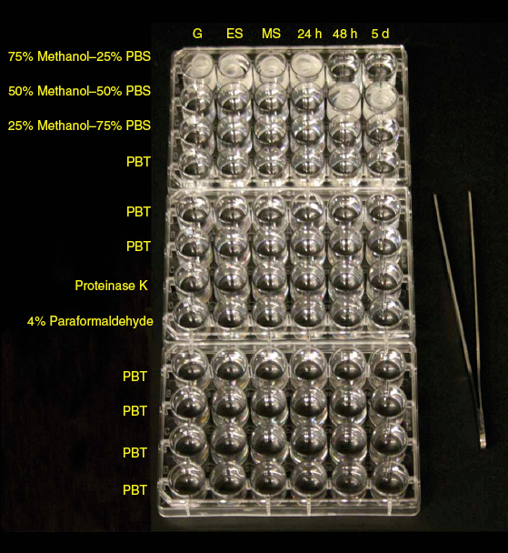
Example of egg rehydratation and permeabilization performed for less than 50 embryos in small baskets and in 24 x well plates.

- Transfer the embryos from their baskets to 1.5 ml sterile eppendorf tubes (up to 50 embryos per tube). At this point, embryos of different developmental stages can be pooled for a given probe until the end of protocol.
- Prehybridize the embryos into 700 µl Hybridization Mix (HM) for 2 - 5 h in a 70°C water bath.
(These prehybridized embryos can be stored in HM at -20°C for up to several weeks).
Note: For strong probes that don’t require long labelling incubation time, heparin and tRNA are not essential and can be omitted.

- Discard HM and replace with 200 µl Hybridization Mix containing 30-50 ng of antisense DIG-labeled RNA probe (from step 12). Hybridize overnight at 70°C. Do not use excessive amounts of RNA probe. This increases background labeling.

Washes and incubation with anti-DIG - antibody-Alkaline-Phosphatase TIMING 7 - 8h and overnight (Day 2)
- Transfer the embryos in HM containing probe into small baskets placed on a styrofoam float (16 x 9 x 1.5 cm with space for 50 small baskets) in a plastic box (21 x 10 x 7 cm) filled with 200 ml of HM (without RNAse free tRNA and heparin) warmed at 70°C, using a pipetter and a 1 ml pipette tip (cut with a scalpel in order to get a 2 mm wide opening).
Embryos remain in these baskets on the styrofoam float in the plastic box until the staining step (step 47). All solutions should be warmed to 70°C prior use.

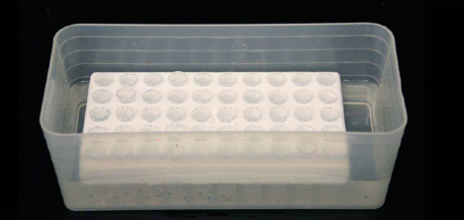
baskets on the styrofoam float in the plastic box

Gradually change the HM to 2x SSC through a series of 10 min, 70°C washes in HM diluted in 2xSSC. Wash once in each of: 75% HM; 50% HM; 25% HM; and 100% 2x SSC. Perform washes in a 70°C water bath with gentle agitation.
HM used in washes does not contain tRNA and heparin.

- Wash twice, for 30 min per wash, in 0.2 x SSC at 70°C.
These high stringency washes prevent non-specific hybridization of the probe.

- Progressively replace 0.2 x SSC with PBT through a series of 10 min washes in 0.2x SSC diluted in 1x PBT. Wash once at room temperature on a horizontal shaker (40 rpm) in 200ml of the following solutions: 75% 0.2 x SSC; 50% 0.2 x SSC; 25% 0.2 x SSC; and 1x PBT.
- Incubate the embryos for 3 - 4 h at room temperature in blocking buffer.
This step saturates non-specific binding sites for the antibody.
- Incubate in 200 ml anti-DIG antibody solution diluted at 1/5,000 - 1/10,000 in blocking buffer overnight at +4°C with gentle agitation (40 rpm on a horizontal orbital shaker).

Washes and staining TIMING 4 h - 11 h (Day 3)
- Discard the antibody solution and wash the embryos briefly in PBT.
- Wash 6 times, 15 min per wash, in PBT at room temperature with gentle agitation (40 rpm on horizontal orbital shaker).
- Briefly dry the embryos by placing the styrofoam float carrying the baskets on a sheet of absorbent paper.
This important step prevents the formation of precipitates in the alkaline tris buffer that would stick to the embryos.
- Incubate the embryos at room temperature 3 times, 5 min per wash, in alkaline tris buffer with gentle agitation (40 rpm on horizontal orbital shaker).
- Transfer the embryos from baskets into 1.5 ml microfuge tubes.
- Remove the alkaline tris buffer and replace with 0.7 ml staining solution prepared fresh and kept in the dark.
The staining solution should be light yellow. If it turns pink, prepare a fresh solution to prevent background staining.
Note: To decrease background and perform long labelling incubation (24h incubation time at room temperature) NBT solution can be decreased 10x (22.5 µl for 50 ml Alkaline Tris buffer).

- Transfer the embryos into spot plates (see Fig 6). Monitor the colour reaction periodically under a dissecting scope, lit from above. Keep the embryos in the dark between checks.
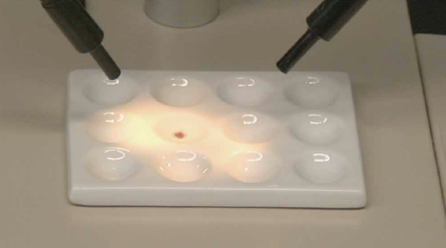
Monitoring the staining reaction
Embryos in staining solution are placed in a spot plate and the reaction is monitored using a stereomicroscope, illuminated from above. Brief observations of the embryos are performed every 10 to 15 min then the plate is placed in the dark to avoid overexposure to light.

- When the desired staining intensity is reached (reaction time in the range of 15 min for highly expressed genes, 1 to 1.5 h for the majority of genes tested and up to 24 h for weakly expressed genes), stop the reaction by transferring the embryos into 1.5 ml eppendorf tubes, discarding as much of the staining solution as possible, and filling the tube with 1 ml stop solution. Wash three times 15 min at room temperature on a test tube rocker with gentle agitation.
Stained embryos can be stored in the dark in stop solution at 4°C for several years.

Mounting embryos TIMING Overnight
- If studying early developmental stages, incubate the embryos for 5 min in 1x PBS pH3.0. Otherwise, proceed immediately to step 52.
By this stage in the Procedure, the yolk cell displays strong photosensitivity and will progressively turn from yellow to orange then brown when exposed to light. For early developmental stages this will affect visualization of the staining as the tissues lay on top of the yolk. This photosensitivity of the yolk can be prevented by 5 min incubation into an acidic buffer (1x PBS pH3.0) before mounting embryos in glycerol. Following this treatment, the yolk cell will stay clear and light yellow for months even under intense light. However, the acidic treatment affects tissue morphology. This should not be used on embryos showing well-formed structures and not on embryos older than the 15 somite stage and for which the yolk can easily be dissected off.
- Transfer embryos, using a pipetter and a 1 ml pipette tip (cut to get a 2 mm wide opening), in the minimum possible volume of stop solution to a 6-well plate containing 100% glycerol. Place on a test tube rocker and agitate gently overnight at room temperature in the dark.
This allows the exchange of water and glycerol. Glycerol is a mild clearing agent that imparts a degree of transparency to the biological material it impregnates.

- Next day, mount the embryos in 100% glycerol (see Equipment setup) and observe microscopically.

- Capture images (see Equipment setup) and save as TIFF files, adjusted for contrast, brightness and colour balance using imaging software.

- Enjoy !

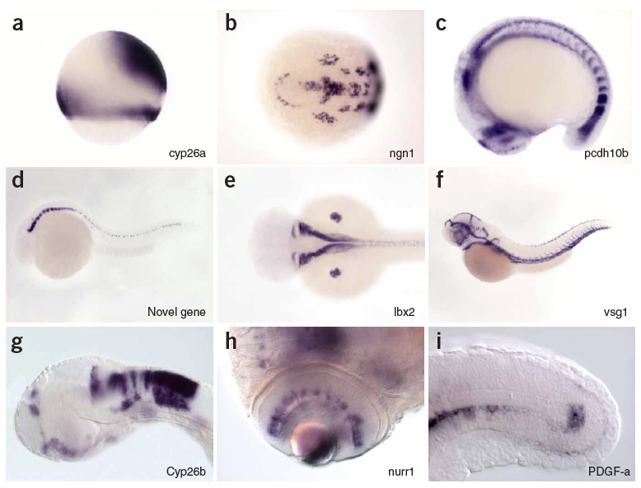

TROUBLESHOOTING

Step | Problem | Possible cause | Solution
13 | Poor RNA synthesis | Use of SP6 RNA polymerase which poorly incorporates digoxygenin-3’ UTP. | Substitute the SP6 promoter with a T3 or T7 promoter.
13 | Degraded RNA on gel | Poor sterility of the products used | Always have everything sterile especially fresh sterile water.
23 | Embryos are not dechorionated or are damaged after Pronase treatment | Pronase treatment applied at the wrong concentration or for the wrong duration. Pronase too old or too concentrated. | Check concentration. Prepare a new batch and standardize conditions of use.  Avoid putting too much water in the beaker on top of the eggs, which dilutes the Pronase. Check time of exposure.
27, 31 | Embryos break during the in situ procedure | Fixation problem.  Agitation too strong.  Too strong Proteinase K treatment. | Respect timing of fixation, always make PFA fresh.  Decrease speed of agitation.  Respect concentration and timing of Proteinase K treatment.
31, 36 | Background in the stained embryos | Hybridization temperature too low.  Hybridization and washes not stringent enough.  Quality and purity of products (especially formamide).  Excess probe. | Respect hybridation temperature, check water bath.  Verify water bath temperature. If necessary, decrease SSC from 0.2x to 0.1x at step 39.  Use only high quality grade.  Decrease quantity of probe used.
49 | No staining | Probe degradation.  Gene not expressed during embryogenesis/larval stages. | Check quality of probe on gel.  Check by RT-PCR for time of expression.
49 | Staining only in superficial tissues | Step 25: Excess fixation (fixation too long or at too high temperature). | Limit fixation to overnight at 4°C in 4% paraformaldehyde in 1x PBS.
49, 53 | Embryos turn pink or brown | Embryos exposed to too much light | Keep labeling solution and stained embryos in the dark.

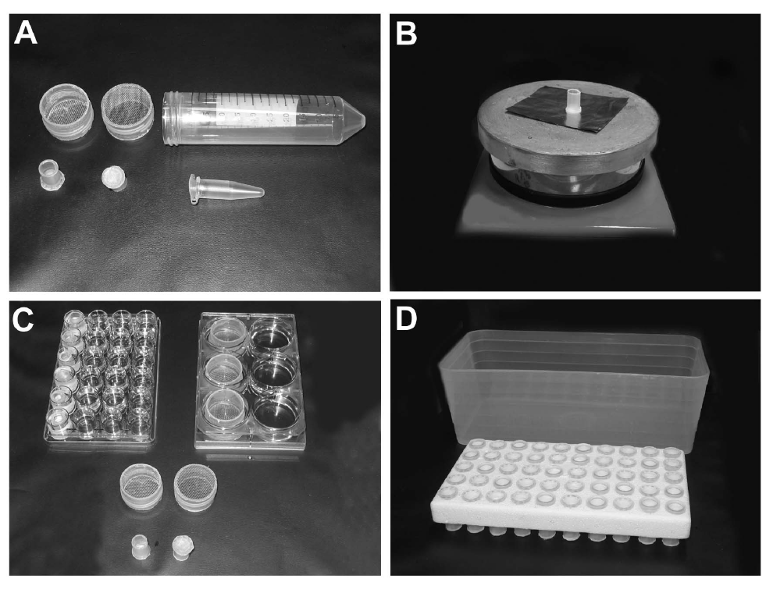
Different devices used for in situ hybridization on whole mount zebrafish embryos.
A : small and large baskets are made from 1.5 ml, 2 ml or 50 ml plastic tubes cut with a saw or a cutter. B : fusion of metal or nylon mesh on the bottom of the plastic tube (place an aluminium foil between the mesh and the hot plate. When the appropriate temperature is reached – this should be tested for each type of plastic – press the tube on the mesh. When the plastic has melted and fused to the mesh, remove the basket – that stick to the aluminum foil – from the hot plate, remove the aluminium foil slowly) . C : incubation of the embryo (day 1) are performed into multiwell plates (24 well plates for small baskets, 6 well plates for large baskets). D : washes from day 2 to day 3 are performed in small baskets made from 2 ml plastic tube placed on a styrofoam float in a plastic box).

MATERIALS – REAGENTS

REAGENTS
- cDNA or genomic DNA
- PCR master mix (Promega, cat. No. M7505)
- Sterile double distilled water
- Trizma® base (Sigma, cat. no. T1503)
- Ethylenediaminetetraacetic acid (EDTA) (Eurobio, cat. no. GAUEDT00-66) see REAGENT SETUP
- Boric acid (Sigma, cat. no. B7901)
- Agarose (Sigma, cat. no. A9539)
- Transcription buffer (Promega, cat. no. P118B)
- DL-Dithiothreitol (DTT) (Promega, cat. no. P117B)
- DIG RNA Labeling Mix (UTP) (Roche, cat. no. 1277073)
- RNAsein (Promega, cat. no. N251X)
- T3 RNA-Polymerase (Promega, cat. no. P207C)
- T7 RNA-Polymerase (Promega, cat. no. P207B)
- RNAse free DNAse I (Roche, cat. no. 776785)
- NaOH (Sigma, cat. no. S8045)
- RNAlater (Sigma, cat. no. R-0901)
- Adult male and female zebrafish (Danio rerio) of comparable size and age (within the range of 3 months to 2 years old). Keep at 28.5°C with controlled light conditions (14h light, 10h dark). CAUTION All animal experiments should be performed in accordance with the relevant authorities' guidelines and regulations.
- Pronase (Protease from Streptomyces griseus, Sigma, cat. no. P6911) see REAGENT SETUP
- Fish water (water from the zebrafish animal facility system)
- Dulbecco’s Phosphate Buffered Saline Modified, without calcium chloride and magnesium chloride. (PBS) (Sigma, cat. no. D-5652)
- Paraformaldehyde (PFA) (Sigma, cat. no. P-6148) see REAGENT SETUP
- CAUTION Noxious substance. Avoid inhalation and contact with the eye and skin. Use protective clothes during preparation and application.
- Methanol (Technisolv, cat. no. prol83809-360) CAUTION Avoid inhalation and contact with the eye and skin.
- 1-phenyl-2-thiourea (PTU) (Sigma, cat. no. P7629) CAUTION Poison. Highly toxic, may be fatal if swallowed or inhaled. Experimental teratogen. Irritant. Safety glasses, gloves, good ventilation, dust mask if powdered product may get into the atmosphere.
- NaCl (Sigma, cat. no. S3014)
- KCl (Sigma, cat. no. P9541)
- MgSO4 (Sigma, cat. no. M2643)
- Ca(NO3) (Sigma, cat. no. C1396)
- HEPES (Sigma, cat. no. H3375)
- H2O2 (Sigma, cat. no. 31642)
- KOH (Sigma, cat. no. P1767)
- Tween20 (Sigma, cat. no. P-1379) see REAGENT SETUP
- Proteinase K (Roche Diagnostics, cat. no. 1092766) Prepare 10 mg/ml stock solution in PBT and store at -20°C in 100µl aliquots. Final concentration for embryo permeabilisation is 10µg/ml.
- Formamide high purity grade (Carlo Erba, cat. no. 452286) see REAGENT SETUP
- Serdolit MB-3 (Serva, 40721)
- Citric acid trisodium salt (Sigma cat. no. C3674)
- Citric acid monohydrate (Sigma, cat. no. C1909)
- Heparin sodium salt (Sigma, cat. no. H-3393)
- tRNA from wheat germ Type V, lyophilized powder (Sigma, R7876) see REAGENT SETUP
- Phenol solution Saturated with 0.1 M citrate buffer, pH 4.3 (Sigma, P4682)
- Chloroform (Carlo erba, cat. no. 438603)
- Sodium acetate (Merck, cat. no. 0095096B)
- Ethanol absolute (Technisolv, cat. no. PROL83813-360)
- Sheep serum (Interchim SA, cat. no. 013-000-121). Resuspend in 10 ml of sterile water, aliquot and store at -20°C
- Albumin from bovine serum, further purified Fraction V, 99% pure (BSA) (Sigma, A3059)
- Sheep anti Digoxigenin-AP Fab fragments (Roche Diagnostic, cat. no. 1093274)
- HCl (Sigma, cat. no. H1758)
- MgCl2 (Sigma, cat. no. 63068)
- Nitro Blue Tetrazolium (NBT, Sigma, N6639). Dissolve 50 mg of Nitro Blue Tetrazolium in 0.7 ml N, N-dimethylformamide and 0.3 ml sterile water and store at -20°C.
- 5-bromo 4-chloro 3-indolyl phosphate (BCIP, Sigma, B-8503). Dissolve 50 mg of 5-Bromo 4-Chloro 3-Indolyl Phosphate in 1 ml of N, N-dimethylformamide anhydrous and store at -20°C.
- N, N-Dimethylformamide anhydrous, 99.8% (Aldrich, cat. no. 227056)
- Na2HPO4, 12H2O (Fluka, 71650)
- NaH2PO4 (Merck, cat. no. 1,06346,1000)
- Glycerol ≥99% (Sigma, G6279)
- Stop solution: 1 x PBS pH5.5, 1mM EDTA, 0.1% Tween 20 (vol/vol)
- 10 x PBS pH5.5 stock solution: 10.8 g of Na2HPO4, 65g of NaH2PO4, 80g NaCl, 2g KCl are dissolved into 1 l of water.
- PBT: 1 x PBS, 0.1% Tween20 (vol/vol)
- 20x SSC stock solution: NaCl 175.3 g, Citric acid trisodium salt 88.2g dissolved in 1l of water.
- Blocking buffer: 1 x PBT, 2% sheep serum (vol/vol), 2mg/ml BSA.
- 0.3 x Danieau medium: 17 mM NaCl, 2 mM KCl, 0.12 mM MgSO4, 1.8 mM Ca(NO₃)₂, 1.5 mM HEPES, pH 7.6
- Alkaline Tris buffer: 100 mM Tris HCl pH 9.5, 50 mM MgCl2, 100 mM NaCl, 0.1% Tween 20
- Tris HCl pH 9.5 see REAGENT SETUP

REAGENT SET UP

1 x TBE: 12.1g Trizma® base, 0.75 g EDTA and 7.6 g Boric Acid dissolved in 1l of water
EDTA 0.5M pH 8.0: dissolve 186.1 g EDTA in 800 ml of water. Add 15 g NaOH pellets and adjust to 1 liter with water when all pellets are dissolved.
Pronase preparation: dissolve 1 g of Protease in 100 ml of 0.3 x Danieau buffer, incubate for 2 h at 37°C, aliquot in 5 ml tubes and store at - 20°C.
4% (wt/vol) paraformaldehyde in 1 x PBS: Dissolve 4 g of paraformaldehyde in 1x PBS and heat until the powder has dissolved completely. When the powder is completely dissolved, cool the solution until it reaches room temperature (18 - 25°C). This solution, stored at room temperature, can be used for a couple of days.
Never boil the solution because paraformaldehyde will be degraded and the medium will acidify due to formation of formic acid.
20% Tween20: stock solution is prepared by diluting 200 ml of Tween20 into 800 ml of sterile water. After complete homogenization of the solution it is stored at room temperature. CRITICAL: Protect this solution from light.
RNAse free tRNA: tRNA from wheat germ Type V, lyophilized powder is resuspended in water at a concentration of 50 mg/ml and extensively extracted several times with phenol/chloroform to remove protein.
Hybridization Mix (HM): 50% deionized Formamide, 5 x SSC, 0.1% Tween20, 50µg/ml Heparin, 500 µg/ml RNAse Free tRNA adjusted at pH6.0 with citric acid (460µl of 1M citric acid solution for 50 ml of HM).
Deionization of Formamide: Add high purity grade formamide to 10g/l Serdolit MB-3 and stir slowly for 15 min; repeat once. Filter the solution to remove the resin and store in the dark at 4°C.
Tris HCl pH 9.5, 1M stock solution: 121.1 g of Trizma® base dissolved in 900 ml of water. The pH is adjusted to 9.5 with HCl, and then the volume is adjusted to 1l with water.
Labeling solution: dilute 225 µl of 50 mg/ml NBT and 175 µl of 50 mg/ml BCIP in 50 ml of alkaline Tris buffer. Protect from light. To diminish background when long incubation time are required, NBT could be decreased 10x (22.5 µl instead of 225 µl).

EQUIPMENT
- Microcon YM-50 columns (Millipore, cat. no. 42415)
- SigmaSpin Post Reactions Purification Columns (Sigma, cat. no. S-5059)
- Breeding tanks (Barloworld, cat. no. ZFT001) with dividers diagonal (Barloworld, cat. no. ZFT002)
- Dissecting stereomicroscope with diascopic stand and a fiber optic illuminator with articulated arms.
- Pipette pump filler (Fisher, cat. no. 13-683C)
- Pasteur capillary pipette 15 cm (VWR, cat. no. 612.1701)
- Pasteur capillary pipette large diameter (diameter of the capillary 2 mm) (Dominique Dutscher S.A. - cat. no. 042000L)
- Incubator (28.5°C)
- Large baskets (see EQUIPMENT SETUP and Fig.3a and 3b)
- Small baskets (see EQUIPMENT SETUP and Fig.3b and 3c)
- Multiwell 6 well plates (VWR, cat. no. 62406-161)
- Multiwell 24 well plates (VWR, cat. no. 15705-060)
- Water bath with agitation (GFL1083)
- Styrofoam float (Scotlab, cat. no. 24106)
- Plastic box (21 x 10 x 7 cm) (Fisher Bioblock, cat. no. 2513H)
- Horizontal orbital shaker (VWR, cat. no. 47742-752)
- Spot plates in white porcelain, 12 cavities (Fisher, cat. no. S337241)
- Test tube rocker varimix (Fisher, cat. no. 12-815-3Q)
- Single end frosted microscope slides 75 x 25 mm, thickness 1 mm (VWR, cat. no. 16004-368)
- Micro cover glasses square (22 x 22 mm) thickness 1 ½ (VWR, cat. no. 48366-227).
- Micro cover glasses rectangular (24 x 40 mm) thickness 1 (VWR, cat. no. 48393-060)
- Super glue (cyanoacrylate) (Fisher, cat. no. 11-999-24)
- Macroscope (Leica microsystems, M420)
- Compound microscope with Differential Interference Contrast (DIC) (Leica microsystems, DM RA2)
- Digital camera (Roper Scientific, coolsnap CCD) linked to a PC.
- Imaging software (Adobe, Photoshop CS2)

EQUIPMENT SETUP
Agarose-coated Petri dishes: Petri dishes used for embryos are coated with a layer of 2% agarose (± 2 mm thick) prepared in distilled water. This prevents embryos sticking to the plastic dish.

Small baskets: These are made from 1.5 ml or 2 ml microfuge tubes. The lid and the conical part of the tube are cut with a box cutter. A 125 µm nylon mesh is fused at the top (1.5 ml tube) or at the bottom (2 ml tube) of the remaining cylindrical part of the tube. To do this, a small piece of aluminum foil is placed on a hot plate. A square piece of nylon mesh (1.5 cm) is placed on the aluminum foil. Then the cylindrical part of the microfuge tube is pressed onto the square piece of nylon to fuse the plastic tube to the nylon mesh. The three components (aluminum foil, nylon and tube) are rapidly removed from the hot plate. The aluminum foil is easily peeled off, leaving a small basket composed of a cylindrical plastic tube closed at one end by a nylon mesh of a size smaller than a zebrafish embryo.
Large baskets: These are made from a 50 ml tube with a conical bottom (Falcon, cat. no. 14-432-22) using the same procedure as the small baskets with the following modifications. The cylindrical part of the tube is cut with a saw to generate a cylinder 1.5 cm high and, instead of using nylon mesh, the tube is fused to a metal grid made of stainless steel with a mesh of 125 µm. The resulting basket fits into 6 well multiplates
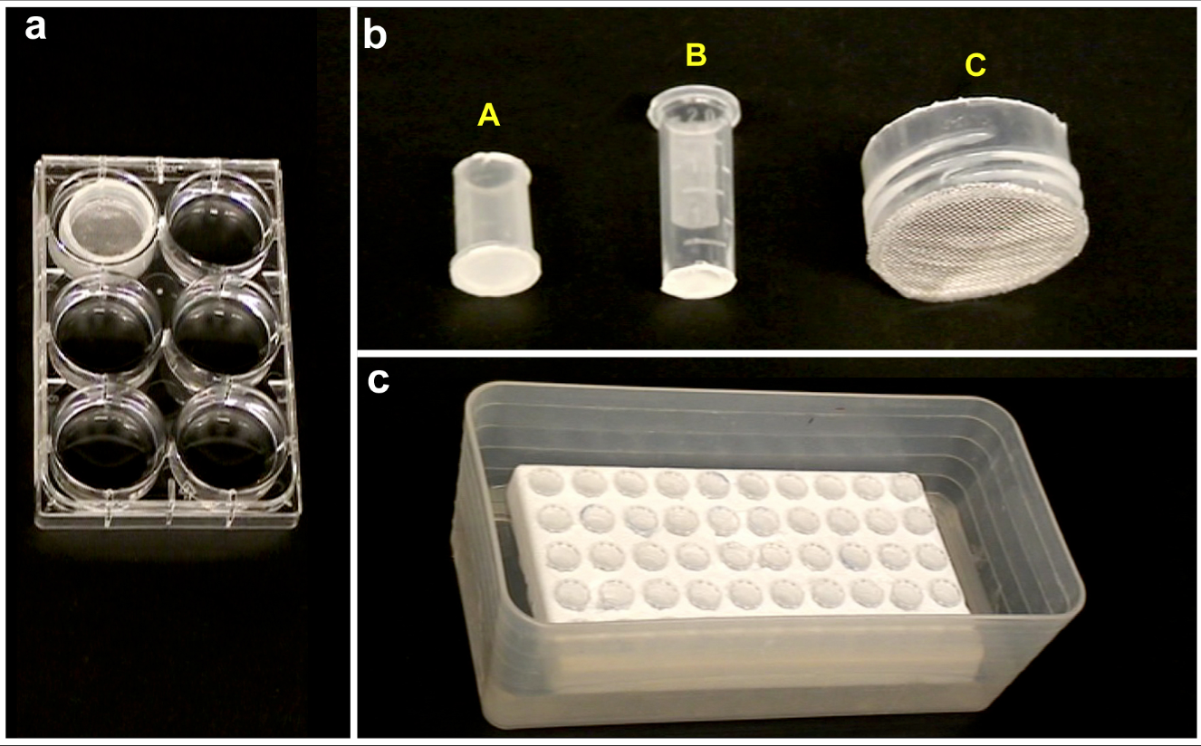
Baskets and boxes used for rehydration, incubation and washes. (a) Large basket made from a 50-ml plastic tube and stainless metal mesh placed into a six-well plate. (b) Small baskets made (i) froma 1.5-ml microfuge tube used for rehydration steps and proteinase K treatment of a small number ofembryos (up to 50) or (ii) from a 2-ml microfuge tube used for washes and incubation with anti-DIG antibody. (iii) Large basket. (c) Fifty small baskets made from 2-ml microfuge tubes placed on a styrofoam float in a plastic box filled with 200 ml of washing buffer.

Mounting embryos: To mount the embryos, 3 (for embryos after 24 hpf) or 4 (for embryos before 24h) cover slips of thickness 1.5 are glued together using a drop of super glue (cyanoacrylate) to make a bridge. A drop of glycerol containing the embryo is placed in the middle of the slide between two coverslip bridges and covered with a larger cover slip (24 x 40 mm, thickness 1). Using this mounting system, embryos can be rolled in all positions (for embryos younger than the 16 somite stage) by gently moving the upper cover slip. For older embryos, elongation of the tail limits the rotation possibilities to rotation around the antero-posterior axis only.

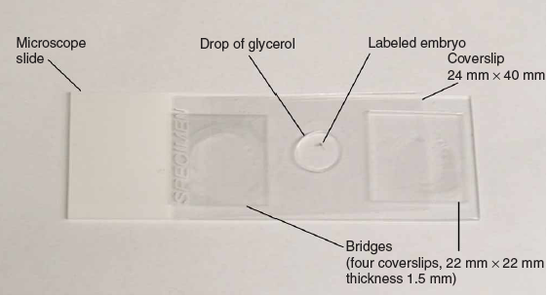
Mounting stained embryos for observation and imaging
After overnight incubation in 100% glycerol under gentle agitation, stained embryos are placed in a drop of glycerol in the middle of a microscope slide between bridges made of 4 coverslips of thickness 1.5. The bridge and the embryo in the drop of glycerol are covered with a large 24 x 40 mm coverslip. Due to the viscosity of the glycerol, the embryo can be rolled and observed in different orientations by gently moving the 24 x 40 mm coverslip.

Capturing images: In our lab, low magnification pictures are taken with a Leica Macroscope, which offers a large field of view and a long working distance. Its vertical beam path provides parallax-free imaging, resulting in highly accurate top quality images. High magnification pictures are taken using a microscope (Leica DM RA2) with differential interference contrast (DIC). Both low and high magnification pictures are taken using a digital camera (Coolsnap, Roper Scientific).

